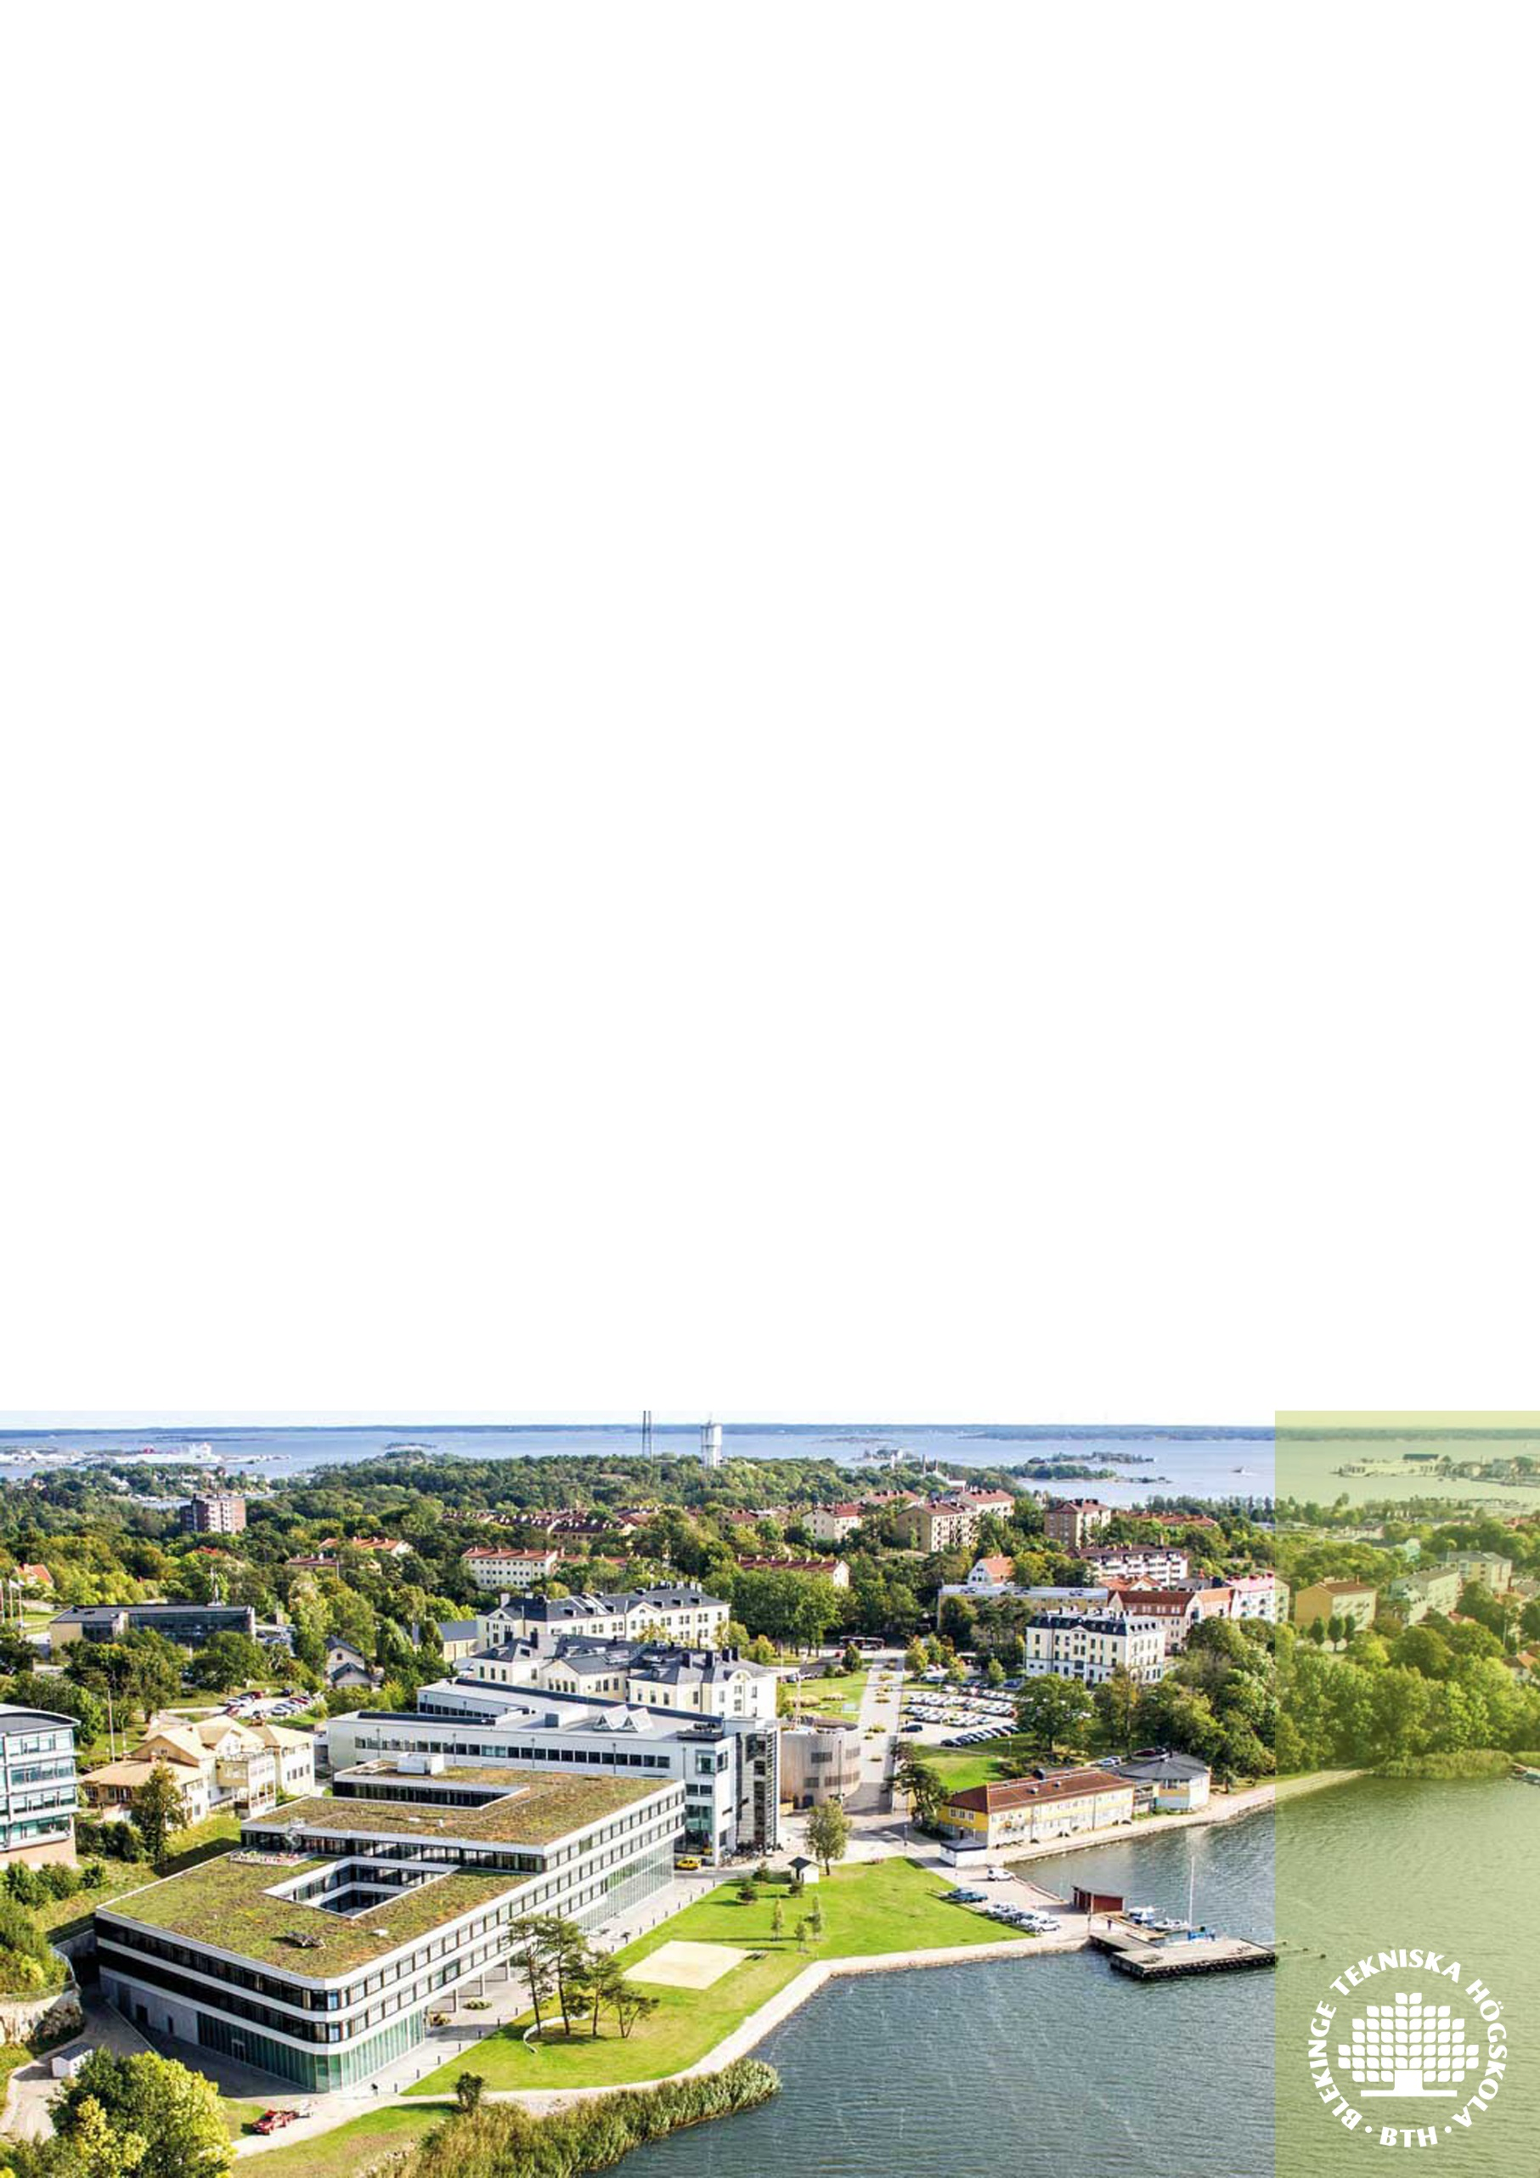
I. Offering:
The International Office at BTH offers a semester long Erasmus+ Work placement as:

International Assistant within the International Office

Blekinge Institute of Technology, BTH, was founded in 1989 and is one of Sweden’s most profiled universities. It offers quality education and training in creative and modern surroundings together with an attractive environment beautifully located by the sea shore of the Baltic Sea. This makes BTH the university with the highest proportion of international students among its total student population of all Swedish universities.

“The International Office at BTH is a warm and welcoming working environment. It was a challenge that I accepted in May 2015 shortly after I had finished my Erasmus+ Exchange Programme at BTH. Until September, among other administrative tasks, I was in charge with the admission files of most of the incoming Erasmus students and to prepare the welcoming event for them. In addition to the experience I gained within this field, I had the chance to get to know other staff members and to understand how it feels like to work within a Swedish environment. Furthermore, I succeeded to improve my Swedish language skills as this was the perfect chance to communicate in Swedish. Working at BTH was the other side of the coin that completed my one year long experience in the naval city of Karlskrona. This is why I would highly recommend this opportunity!
”
Andreea Blaga, International Assistent May-September 2015
“My main task during the internship is to organize the International Day. A Day of cultural diversity, a Day of internationalization. After my graduation in International Relations and Diplomacy, I considered that working on this project was an opportunity to practice the acquired knowledge from the university studies. The environment within the International Office is friendly. I also have opportunity to get familiar with the daily administrative activities concerning the Erasmus+ Programme and to meet people from all around the world. Working with students is a challenge and I like it. Every day they come up with new questions and it makes my job even more interesting.
”
Romana Mjartanova, International Assistent August 2015-present

II. Outline of the proposed training

Planned dates:
August 15th 2016 – December 18th 2016

Tasks of the trainee:
Participate in the daily work of the International Office for 8 hours per day (regular Swedish working hours).
Help out the International Coordinators with various tasks.
Participate in small scale trainings regarding the programs and databases you will use: Lotus Notes, Ladok, Outlook
The intern will have the following work tasks during the internship;
Project “International Day 2016”
The intern will have the role as coordinator, which means responsible for planning, organizing and administrating an International Day at BTH. This day will take place on November 2016 . This is a big project and the intern will mainly focus on this project. Some of the work tasks;
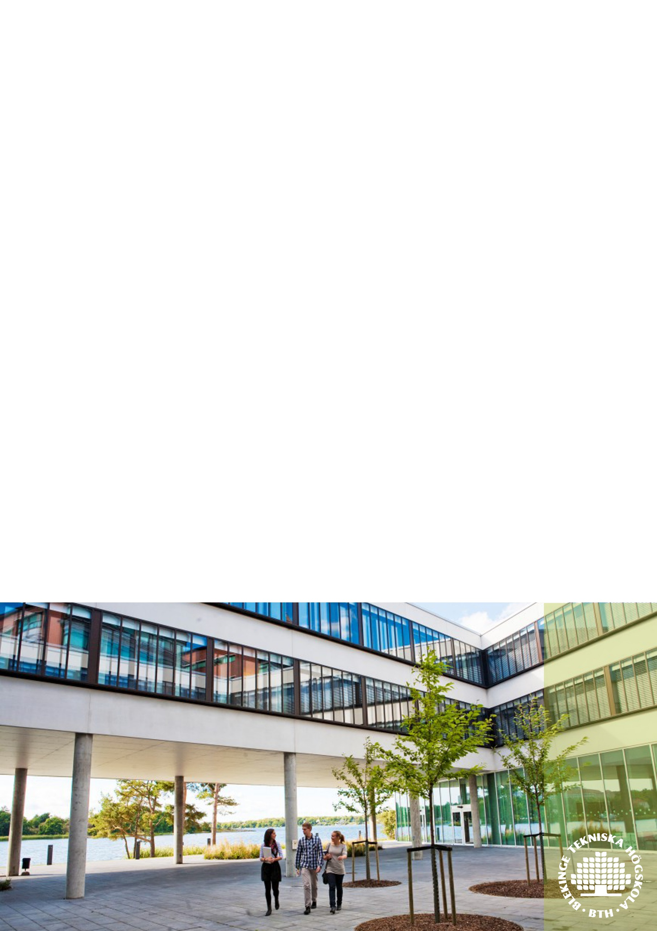
- Project organization and project plan
- Information and marketing
- Budget and purchase
- Collaboration with students
General administrative work tasks at International Office
Other work tasks at International Office

Knowledge, skills and competence to be acquired:
Acquire insights in the structure and work of BTH, specifically regarding the International Office.
Acquire an understanding of how to work with international students.
Acquire an understanding regards work with international partnerships for mobility programs.

III. Background and requirements of applicants

Applicants from different academic fields and backgrounds are welcome to apply for the internship. The applicant has to have completed a two years of successful studies at university level at the start of the placement. Being familiar with the Erasmus+ Mobility Exchange Programme represents an advantage for the application. High English communication skills, verbal and in writing, are required. Both Swedish language skills and experience within a student union will be also merited. An application including support documents from the home university, CV and a motivation letter should be sent to in.exchange@bth.se .

Deadline for application:

April 15th 2016

